# Experiment 1: Hardware with Potenciometer instead of DAC

*Note: In folder 'results and MATLAB script' you have results in txt file and MATLAB script so you can easily zoom interesting parts of figures shown below. (You can use Ernad's LogPlotter for the second experiment where we have DAC values because his software needs 'dac_value' file to show results, this is my mistake, I forgot to mention him about this problem, but we will fix it).*

In this experiment, I use 10k potentiometer between Vref and GND, the middle point of the potentiometer is connected to Vc pin of OCXO using 10k resistor (see image below).

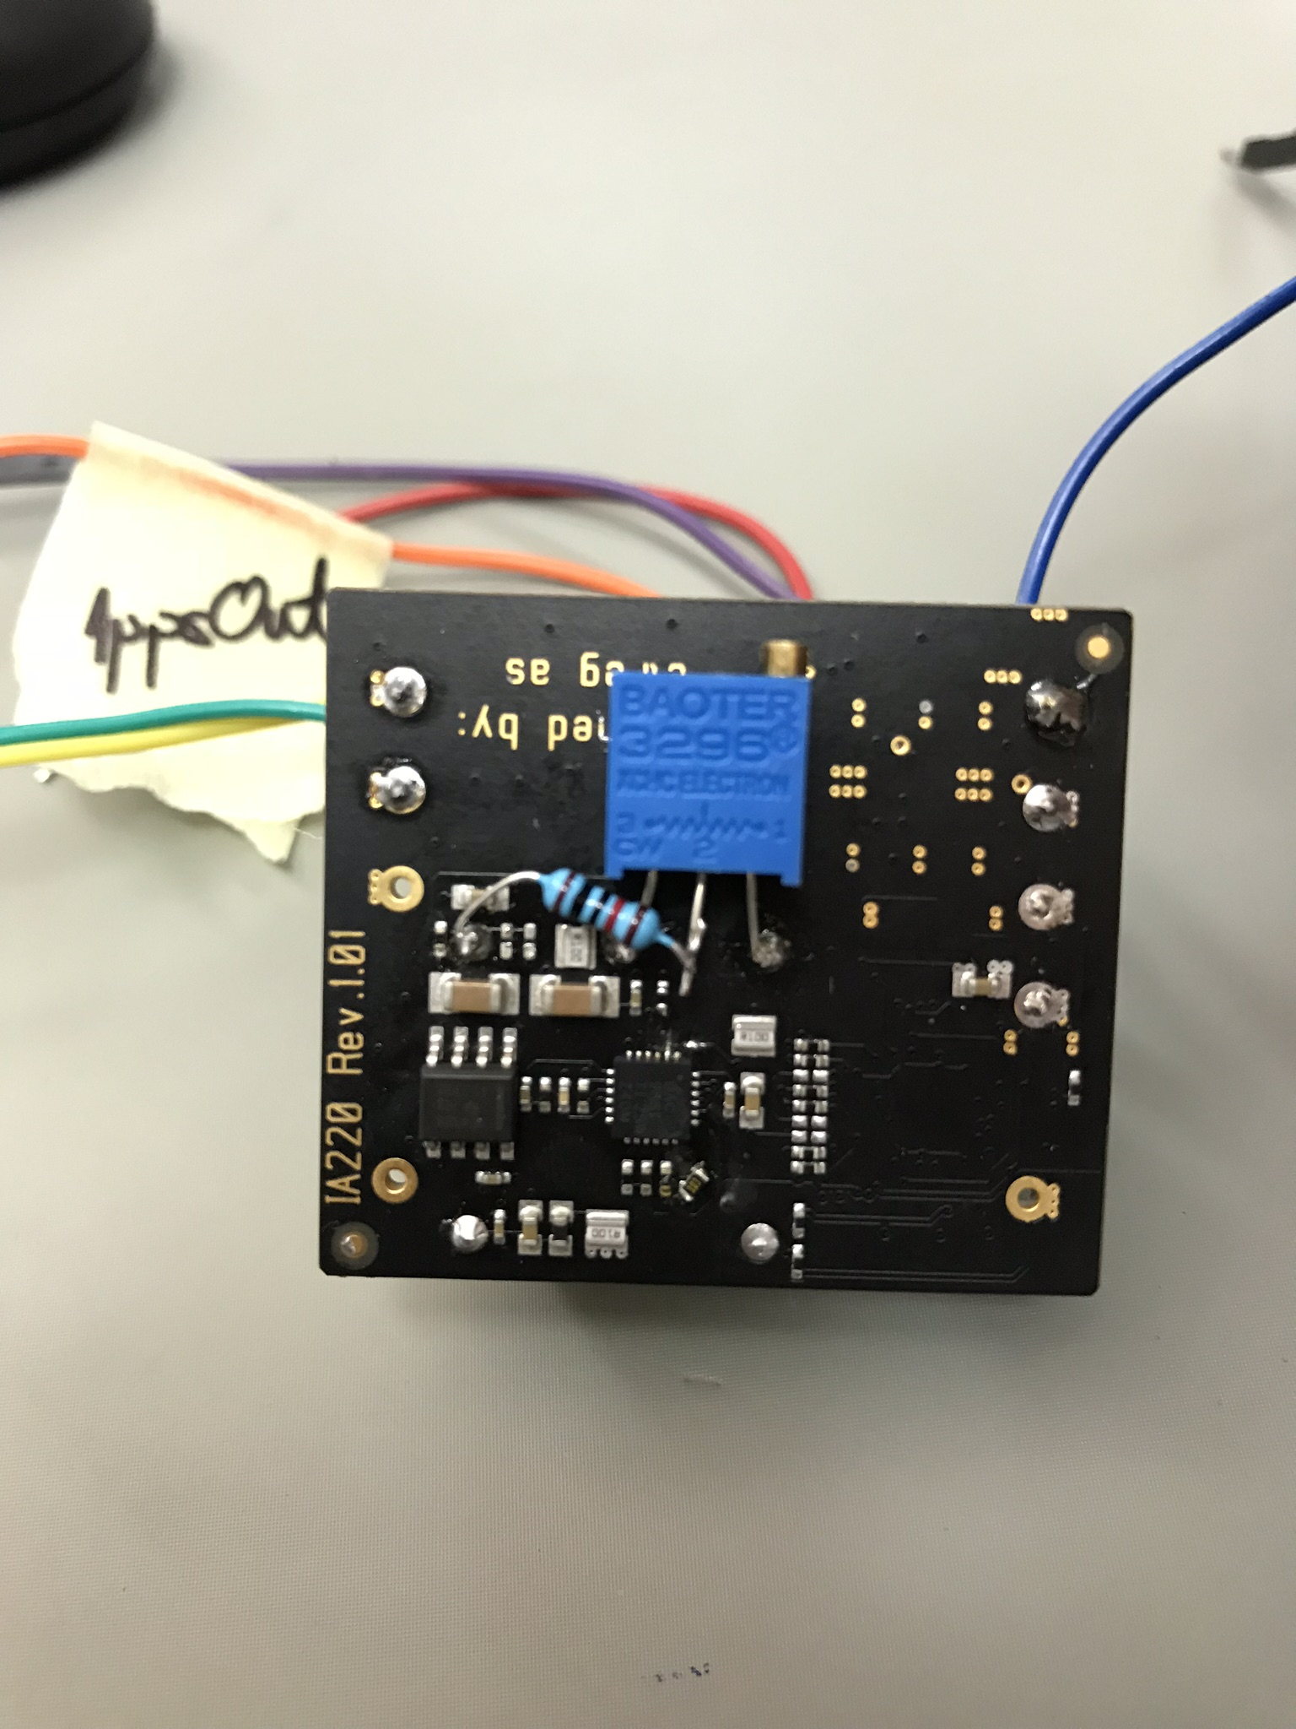

Figure 1: Connection between OCXO and Potentiometer.

First thing was to adjust potentiometer, and after 1800 second freerunning mode started. This three images below shows phase difference, delta phase, and temperature. In order to extract some more information, I use delta phase, which is calculated: DeltaPhase = Phase(n) – Phase(n-1), to see how much phase is changed between every second. *(All images you can find in the images folder, or plot them using MATLAB).*

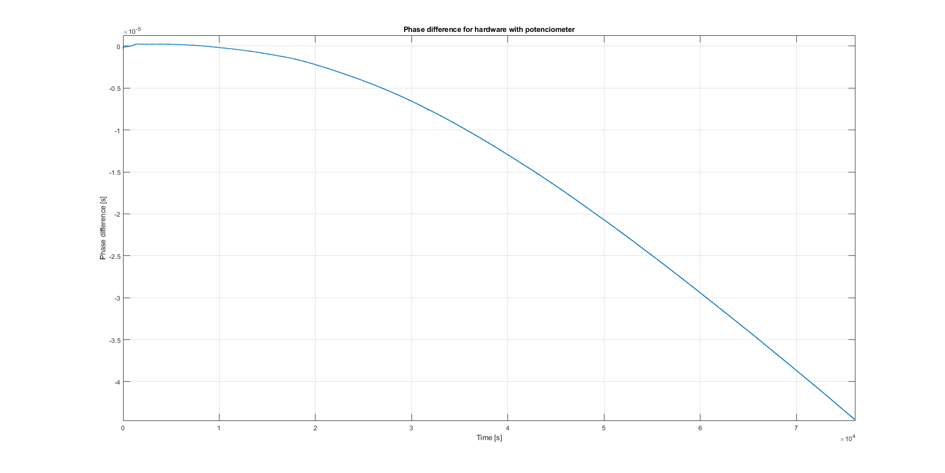

Figure 2: Phase difference for hardware with potentiometer.

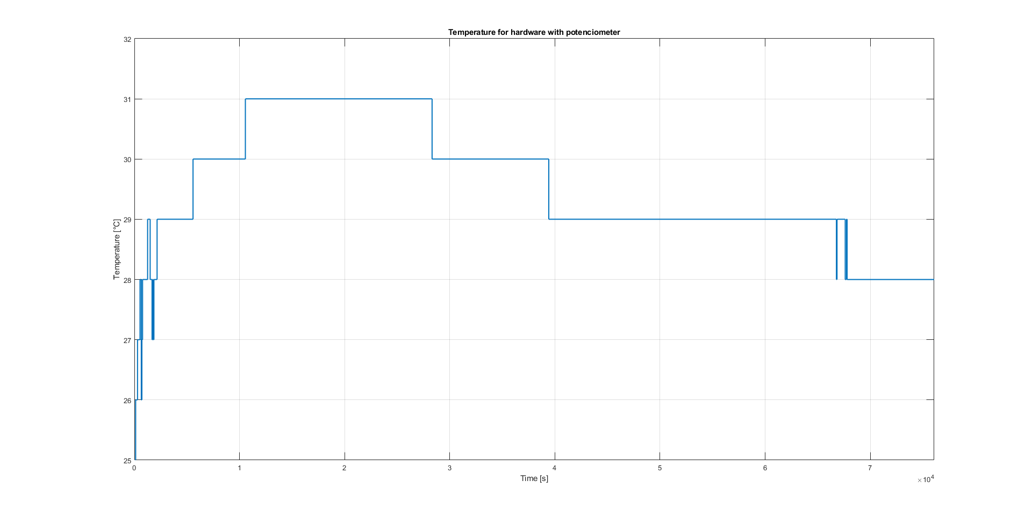

Figure 3: Temperature measurements for hardware with potentiometer.

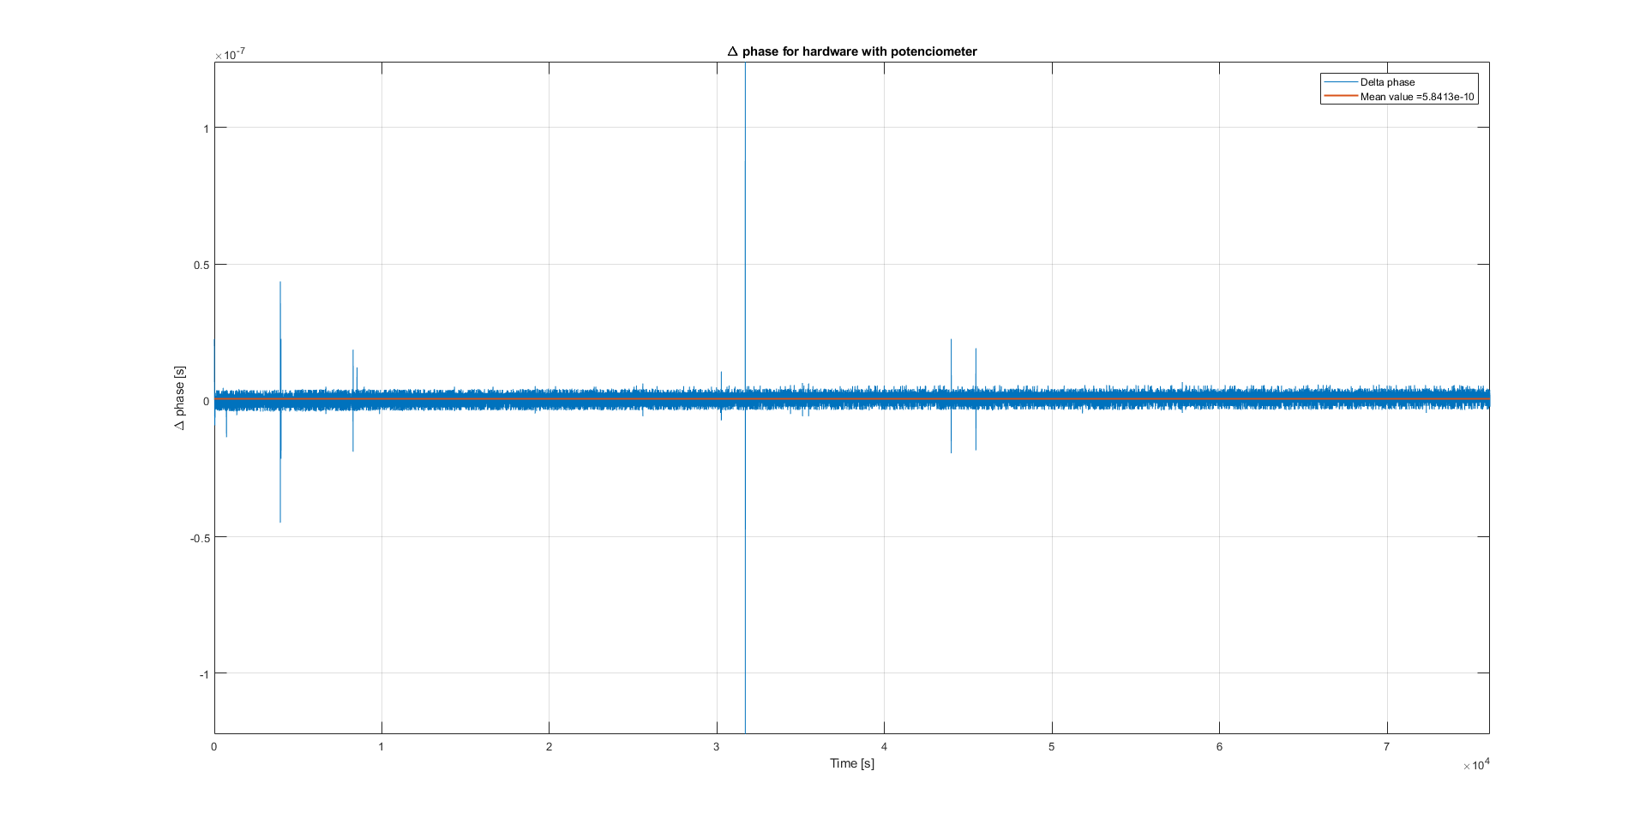

Figure 3: Delta phase for hardware with potentiometer (Mean value is 5.8413e-10).

# Experiment 2: Hardware with DAC

In this experiment I used Hardware with DAC, images below show as results of this experiment and after images, you can find comparison and conclusion. Both experiments have aprox. same length, and as I mentioned earlier, you can also plot this results using MATLAB script and in this case using Ernad's LogPlotter. (freerunning mode started at 5200 seconds).

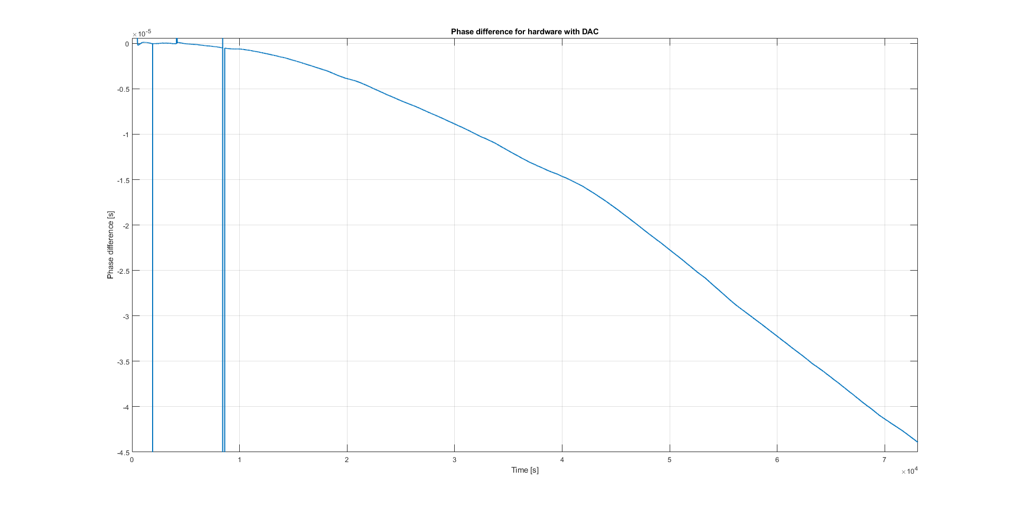

Figure 4: Phase difference for hardware with DAC.

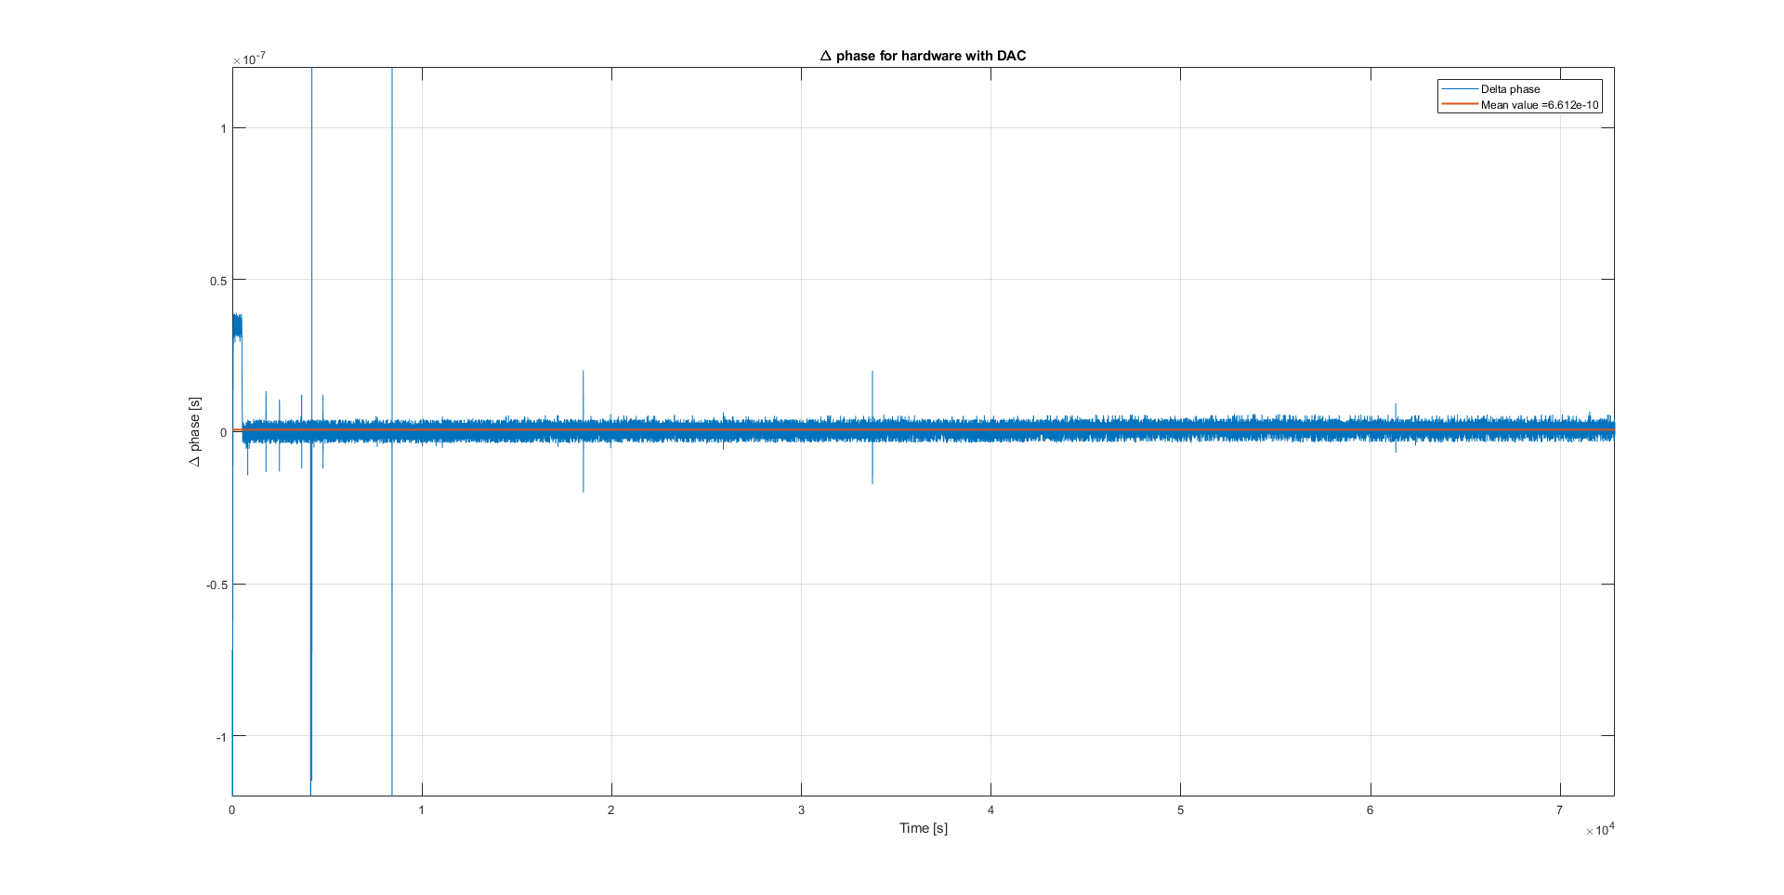

Figure 5: Delta phase for hardware with DAC (Mean value is 6.612e-10).

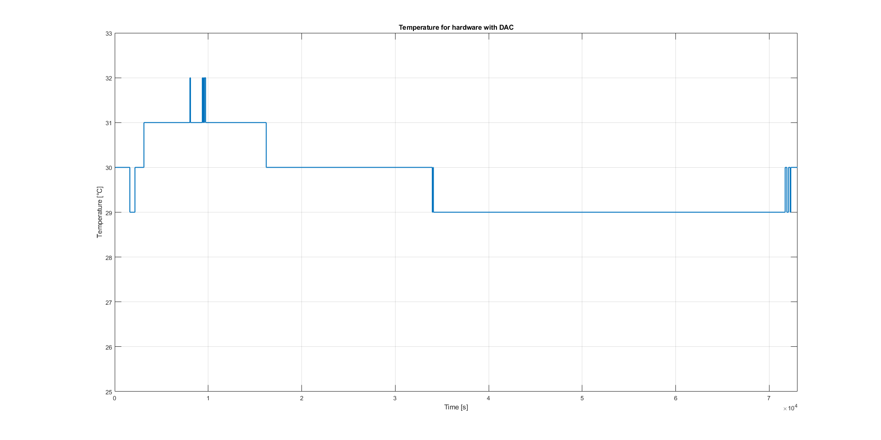

Figure 6: Temperature measurement for hardware with DAC.

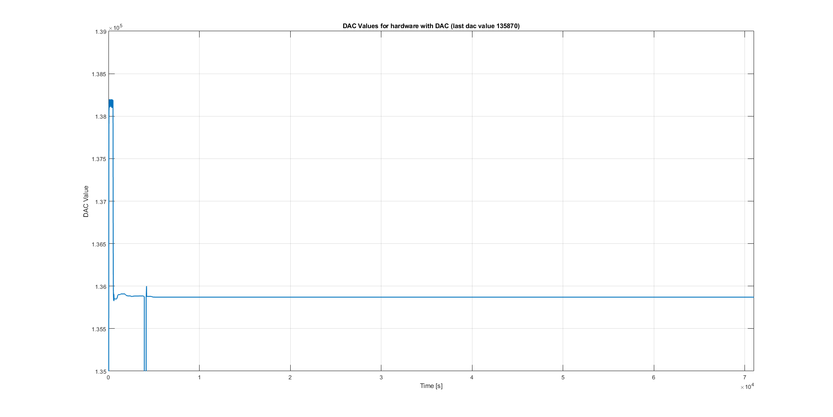

Figure 7: DAC Values.

# Comparison and conclusion:

If we look at figures 2. and 4. we can see that phase difference curve at fig. 2. is much smoother than at fig. 4. These experiments were done in order to make conclusion does DAC has stable output or not. In my opinion, in this case, I think that we don't have a stable DAC output at this hardware (but I can't measure small voltage changes at my oscilloscope). In order to verify this experiment what do you think about this, on second hardware where I have functional DAC, to remove R27 resistor which connects Vc pin of OCXO with DAC (I do the same thing on hardware where I already mount potenciometer), and after that to mount potenciometer with 10k resistor on Vc pin. In that case, if we have a smooth phase difference curve, I think that we can say with high probability that we have unstable DAC output or unstable contoll voltage of OCXO.